**Dependence of Exciton Transport on Solvent Quality in Conjugated Polymer Nanoparticles**

Louis C. Groff, Yifei Jiang, Xiaoli Wang, and Jason D. McNeill

**KEYWORDS**

Diffusion, Energy Transfer, Lattice Gas Model, Swelling, Anisotropy

**ABSTRACT**

The effect of varying solvent quality[better to say “solvent-induced swelling”, since I think of solvent quality as more relevant for miscibility/solubility phase diagrams for dissolved polymer chains, in equilibrium, whereas swelling is what happens to particles and probably does not correspond to the thermodynamic minimum (which would be a slab of bulk swelled polymer or molecules in solution), but rather a kinetically trapped particle state] on observed quenching phenomena and exciton dynamics of conjugated polymer nanoparticles was investigated by steady-state and time-resolved fluorescence spectroscopy. A lattice gas model[not really a lattice gas unless most sites are vacant] incorporating exciton diffusion and energy transfer was employed to elucidate the relationship between structural swelling [is “structural swelling” a legit scientific term?] and reduction in quenching by defects. Time-resolved fluorescence anisotropy decay was measured to further determine exciton diffusion parameters.[finding parameters is rarely a good enough reason to do an experiment--sounds like stamp-collecting] The results indicate highly efficient quenching in poor solvent conditions, which was reversed completely at high THF concentrations.[put it in terms of swelling, polymer chain conformation. make it punchier and more interesting] Steady-state and time-resolved data suggest that the nanoparticles and free polymer coexist [this is more of a side-note, so maybe doesnt belong in the abstract] for both PFBT and MEH-PPV at a narrow range of THF concentrations. The simulation results show good agreement [not interesting. too choppy] with experimental data prior to nanoparticle dissociation. Fluorescence anisotropy decay results indicate that ~32 exciton hops occur within the lifetime of the swelled nanoparticles and ~3 hops occur within the lifetime of PFBT in THF.[what does htis tell us about the nature of exciton transport processes? big-picture?]

[issues: (1) sentence order. Does it make sense to first talk about experiment, then switch to theory, then experiment, then back to theory? (2) Too many short, choppy sentences that don’t flow together. (3) the “who cares” factor. Why would we want to “further determine exciton parameters”? It’s all too “just the facts, ma’am.” Where are the big ideas and broader themes? How does this fit in with what we think we know about CPs? What are the big surprises? What are the big take-home messages? Why does it matter? (4) the words/sentences I’ve highlighted are either problematic, wrong, correspond to points 1-3, or are bad word choices, IMO. I’ll leave it to you to try to figure it out and fix it.]

**INTRODUCTION**

Conjugated polymers have, and continue to garnish a great deal of attention[awk], owing to their applications to low-cost photovoltaic and light emitting diode technologies.1,2 Conjugated polymer nanoparticles (CPNs) are well-suited biological imaging applications, given their extraordinary photostability, brightness, and two-photon cross-sections, as well as their ability to be functionalized for cellular uptake.3-9 CPNs are also of interest as a model multi-chromophore system, a model system for coupled spins, or a model quantum mechanical spin glass.10[need more refs, at least one for each item in the list. also, maybe need “confined” and “energetically disordered” for the spin glass. Also, it is really the excitons that are spin-glass-like, not the CP.] In order to better utilize conjugated polymers for these applications, it is necessary to delve deeper into[awk] the complex photophysics exhibited by these materials, as they are sensitive to[need something punchier, more direct.] polymer structure and processing conditions. The principal neutral photoexcitation in conjugated polymers is the Frenkel exciton.11,12 Energy transfer in conjugated polymers typically occurs via incoherent, diffusion-like processes,13-15 dispersive transport,16 and in certain cases, by long-range coherent transport.17 ~~It has been demonstrated that~~ conjugated polymers exhibit excellent Förster transfer to both dye and polymer dopants, allowing for red shifted emission in imaging applications.18-20 Excitations are delocalized along several chromophores[phrasing], each ~~typically~~ consisting of ~~several~~[one or more] monomer units.[there is a recent paper that seems to indicate that PFBT spectrum is nearly identical to monomer spectrum, so probably better to say “one or more”] Exciton diffusion occurs via transition dipole mediated Förster energy transfer to ~~adjacent~~nearby chromophores.21 Excitons may be quenched by [energy transfer to?] dopant species, nonfluorescent defect sites, photogenerated hole polarons, or aggregate species, including H- and J-aggregates, excimers, and exciplexes.22-27 Chromophore density in conjugated polymers is mainly a result of the structure that chains adopt as a result of their solvent environment.[awkward. unclear] ~~It is understood that~~ abrupt introduction into a poor solvent environment such as water results in chain collapse, where the polymer chains ~~seek to~~ adopt conformations that minimize energetic contributions by surface tension [awk], resulting in either spherical or ellipsoidal nanoparticles, depending on size.28 Chromophore density is greatly increased as a result [awk, unclear. maybe include something about “tightly-packed structure” or similar], which facilitates exciton diffusion[instead, maybe “energy transfer between chromophores”? Also, the key fact of strong distance dependence of ET rate seems relevant here, to help the explanation make more sense and give a fuller physical picture]. As solvent quality[fraction of organic solvent?] is increased ~~gradually~~, the entangled chain structures of CPNs swell, and eventually cause nanoparticle dissociation.[your explanation seems to conflate time and solvent composition in a very confusing way. also, I think of the dissociation as more of a side issue that doesn’t merit discussion in introduction] We have found that nanoparticle swelling and dissociation leads to a two-state system prior to complete dissociation, evidenced by steady state spectra and time resolved lifetime data. A similar conjugated polymer system has been shown to exhibit two-state lifetime dynamics as a function of temperature.29[not here, see above] Another useful question to probe in these systems is the relative measure of how many exciton hops occur within the mean excited state lifetime. This can be assessed using fluorescence anisotropy decay in conjunction with more typical lifetime methods.30 [this should be unpacked a bit more. Some explanation of the picture, the difficulty of resolving it by ordinary non-polarized measurements (is it more frequent, smaller jumps or slower jumps over larger distances that gives rise to the measured exciton diffusion length? Perhaps some mention of the previous dye-doped experiments as giving a picture of the exciton diffusion length and the complexity caused by intrinsic quenching. There is a lot of ground that is relevant here, that you have omitted. There probably need to be 2-4 more paragraphs]

**EXPERIMENTAL METHODS**

**Materials.** The copolymer poly[(9,9-dioctylfluorenyl-2,7-diyl)-*co*-(1,4-benzo-{2,1',3}-thiadiazole)] (PFBT, MW 10,000, polydispersity 1.7), and the poly(phenylene vinylene) derivative poly[2-methoxy-5-(2-ethylhexyloxy)-1,4-phenylenevinylene] (MEH-PPV, MW 200,000, polydispersity, 4.0) were purchased from ADS Dyes, Inc. (Quebec, Canada). The fluorescent dye fluorescein was purchased from Life Technologies (Invitrogen, Eugene, OR). The fluorescent dye Lucifer Yellow CH dipotassium salt (LY, 1 mg/mL in water), solvent tetrahydrofuran (THF, anhydrous, inhibitor-free, 99.9%) and sodium hydroxide (SigmaUltra, minimum 98%) were purchased from Sigma-Aldrich (Milwaukee, WI). All materials were used as provided without further purification.

**Nanoparticle Preparation.** The preparation of fluorescent nanoparticles was performed via a previously described nano-precipitation method.31 The conjugated polymers PFBT and MEH-PPV were dissolved in THF by gentle agitation and prepared at a concentration of 1000 ppm. An aliquot of each stock solution was used to prepare precursor solutions at 20 ppm. A 2 mL quantity of a given precursor solution was rapidly added into 8 mL of deionized water under bath sonication at a frequency of 40 kHz and room temperature. Removal of THF was accomplished by the following procedure. Nanoparticle suspensions were placed in a vacuum oven and pumped down to an atmosphere of -27 in. Hg[<10 torr using a two-stage rotary vane pump]. The samples were kept at room temperature for one hour to prevent bumping, followed by heating at ~40 °C for 8-10 hours to remove most of the remaining THF. The total volume of liquid was reduced by typically XX% during the vacuum evaporation process. The aqueous samples were vacuum filtered through a glass fiber prefilter to remove larger aggregates and a 0.1 µm PVDF membrane filter (Millipore). The resulting suspensions are clear (not turbid) and stable for months with no visible signs of aggregation.

**Characterization Methods.** UV-Vis absorption spectra were acquired using a Shimadzu UV2101PC scanning spectrophotometer with 1 cm quartz cuvettes. Fluorescence spectra and fluorescence quantum yield were measured using a commercial fluorimeter (Quantamaster, Photon Technology International) using 1 cm quartz cuvettes.

Picosecond fluorescence lifetimes and fluorescence anisotropy decay (FAD) were measured under nitrogen using a home-built setup for time-correlated single photon counting (TCSPC) spectroscopy operating in reverse mode. Frequency doubled pulses (420 nm) from a passively mode-locked Ti:Sapphire laser (Coherent Mira 900, 840 nm pulses, ~150 fs pulsewidth) were used as the excitation source for the nanoparticle samples. Sample emission was collected with perpendicular geometry to the excitation source after passing through a 460 nm long pass filter, and a [calcite?] Glan-Taylor polarizer (Thorlabs, GT10-A) oriented either parallel (0°), perpendicular (90°), or at magic angle (55°) to the vertically polarized excitation pulses. All three polarization angles were utilized for FAD, magic angle polarizer orientation was adopted for TCSPC. The output of a single photon avalanche photodiode (APD, id Quantique, id100-50) ~~resulting from detection of single fluorescence photons~~ was used as the start timing pulse for a time-to-amplitude converter (TAC, Canberra Model 2145), and the output of a fast PIN diode (Thorlabs, DET210) was used as the stop pulse, in a standard reverse-mode configuration.[ref] The excitation ~~intensity~~power was attenuated (usually between ~300 µW and 1 mW) to maintain a ~~raw~~ count rate ~~on the APD~~ of ~400 kHz ~~for TCSPC~~as measured at the APD.[note: “raw” is lab jargon/shorthand and is not appropriate for paper, typically] ~~For FAD, the excitation intensity is kept ~300-400 µW.~~ ~~The emission intensity yields between 200 kHz and 800 kHz raw APD counts depending on the sample and polarizer orientation.~~ The analog TAC output was digitized using a multi-channel analyzer (FastComTec, MCA-3A). Before and after each measurement, an instrument response function (IRF) was measured using scattered excitation light from a dilute suspension of polystyrene microspheres. The width of the IRF was determined to be ~70 ps (fwhm). Typical signal-to-noise ratios (SNR) were between 200:1 (80%-100% THF samples) and 500:1 (IRF and low-mid % THF samples).[somewhere above should mention acquisition duration, number of individual acquisitions performed, and number of different samples used for each %THF. Also, SNR was at the peak, right? that should mbe mentioned]

**Swelling Procedure.** In addition to nanoparticles in water and polymer in THF, swollen nanoparticle samples were prepared by diluting an aliquot of concentrated nanoparticle suspension with the appropriate volume of water, then THF [was slowly added?] to produce 3 mL of suspension~~solution~~ with volume ratios of THF/water between 0.2 and 0.95. Each sample was gently agitated to ensure solution homogeneity. The sample absorbance was kept at or under ~0.05 (~0.02 for 95% THF). Samples were purged with nitrogen for ~2 minutes to maximize oxygen removal while minimizing THF losses at higher THF ratios.[awkward]

**RESULTS/DISCUSSION**

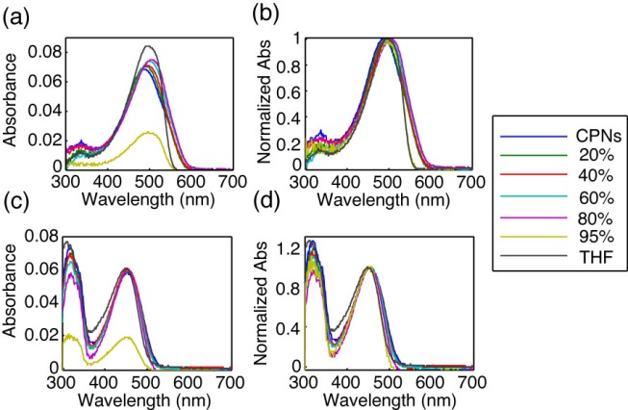

**Fig. 1.** (a,c) ~~Raw~~Absolute and (b,d) normalized absorption spectra of MEH-PPV (top) and PFBT (bottom) at varying volume % THF.[I don’t think we really need the “raw” spectra]

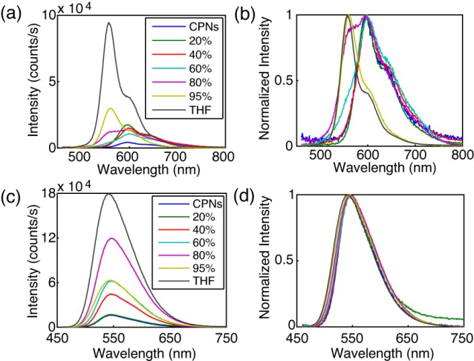

**Fig. 2.** (a,c) Raw and (b,d) normalized emission spectra of MEH-PPV (top) and PFBT (bottom) at varying volume % THF.

**~~Spectral Analysis of Solvent Quality Data.~~Effect of solvent composition on UV-vis and fluorescence.**[it’s awkward to use the word “data” in a heading] The resulting[don’t use “resulting” without a clear antecedent in the same para.] UV-Vis and fluorescence spectra (both normalized and raw) of PFBT and MEH-PPV as a function of solvent ~~quality~~composition are given in Figs. 1 and 2. The absorption spectra of PFBT are fairly invariant with increasing THF, with a ~5 nm total blue shift, and slight broadening of the THF sample spectrum. The emission spectra show a monotonic increase in fluorescence intensity as THF concentration increases, and the spectra also exhibit a blue shift ~5 nm over the course of increasing %THF. The absorption spectra of MEH-PPV maintain a similar shape over the course of THF addition,[awk] though the 95%-100% THF samples are narrower than the other samples.[I thought the samples were all 1 cm?] The absorption peak of MEH-PPV red shifts a total of ~15 nm from 0%-80% THF, and then blue shifts ~7 nm for the high THF samples.[awk] The emission peak blue shifts a total of ~40 nm over the course of increasing solvent quality, and it is evident at ~40% THF and higher that there are two phases present in solution by both the increasing blue shoulder on the spectrum, and the reduction in intensity of the red portion of the spectrum.[unclear] An approximate isosbestic point can be seen [at?] ~580 nm ~~at~~[over the range of?] ~80%-XX% THF.

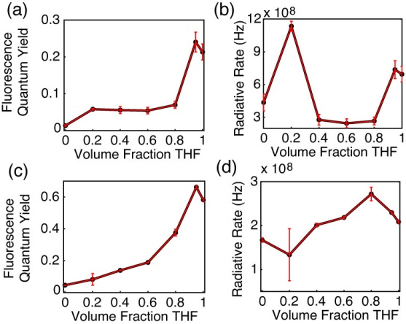

**Fig. 3.** (a,c) Fluorescence quantum yield and (b,d) radiative rate vs. THF volume fraction for MEH-PPV (top) and PFBT (bottom).[lines in figures are bad, unless there is a function you are fitting. Also, Matlab habit of hiding the exponent in the title line is bad. It should be in the axis label. Also, consider using symbol Phi for QY, and *kr* for radiative rate so axis labels are not so crowded.]

The fluorescence quantum yield[s] ( and [calculated?] radiative rate[s] ~~calculations~~,[what, are you showing the algebra?] where the radiative rate is defined as are given in Fig. 3. The quantum yield of PFBT increases monotonically with increasing THF. However, MEH-PPV shows an initial [intensity?] increase from 0%-20% THF, followed by the quantum yield staying relatively consistent from 20% to 80% THF, then increasing at higher %THF. The higher quantum yield of the 95% sample relative to the polymers in THF is ascribed to the uncertainty in the absorbance at such low concentrations of PFBT and MEH-PPV, though it still falls within normal measurement values.[???] The unvarying quantum yield[awk] for MEH-PPV at moderate %THF can be ascribed to the trade-offs in intensity as the blue edge of the spectrum increases and the red edge decreases.[unclear] The radiative rate varies over a factor of ~2 for PFBT and a factor of ~4 for MEH-PPV over the course of increasing solvent quality. This could suggest that transition dipole coupling is somewhat stronger for MEH-PPV, but neither system is particularly strong.[unclear][note: make sure this is discussed in more depth somewhere, since the transition dipole coupling also gives more of a red-shift, and could also affect FRET and thus exciton diffusion constant. The question of why fluorescence exhibits a strong additional redshift for MEHPPV upon NP formation, while the abs does not, may indicate that only a small fraction of the MEHPPV chromophores have strong coupling.]



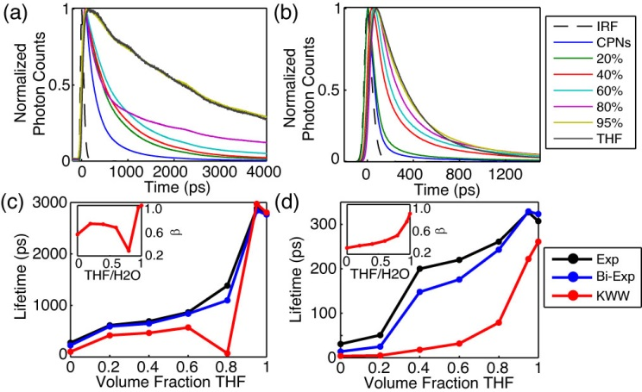

**Fig. 4.** (a,b) Normalized fluorescence intensity decays, and (c,d) lifetimes resulting from single exponential, bi-exponential weighted average, and KWW trial functions with stretch parameter  insets) versus THF volume fraction for PFBT and MEH-PPV, respectively.[similar issues as for previous fig, for parts c, d. Also, if a key data point is at 0 or 1 on x axis, then you need to move the left box slightly to the left (maybe 4-10 points, and place a tick at zero, and do similar at right side. If you can’t do it, send the EPS or PDF to me, and I can do it without hopefully mangling the data or making the plots different sizes]

**Table 1.** Summary of bi-exponential lifetime Data for MEH-PPV and PFBT CPNs, including weighted average amplitudes and individual exponential time constants.[use *1*, *A1*, etc, with subscripts, italics]

|  |  |  |  |  |  |  |  |  |
| --- | --- | --- | --- | --- | --- | --- | --- | --- |
| **%(v/v) THF** | **MEH-PPV** | | | | **PFBT** | | | |
| **Amp1** | **1 (ps)** | **Amp2** | **2 (ps)** | **Amp1** | **1 (ps)** | **Amp2** | **2 (ps)** |
| **0** | 0.964 | 9 | 0.036 | 152 | 0.593 | 88 | 0.407 | 421 |
| **20%** | 0.931 | 14 | 0.069 | 176 | 0.513 | 261 | 0.487 | 941 |
| **40%** | 0.734 | 56 | 0.266 | 401 | 0.507 | 277 | 0.493 | 1029 |
| **60%** | 0.749 | 74 | 0.251 | 482 | 0.554 | 364 | 0.446 | 1427 |
| **80%** | 0.752 | 120 | 0.248 | 616 | 0.649 | 231 | 0.351 | 2700 |
| **95%** | 0.795 | 218 | 0.205 | 761 | 0.024 | 234 | 0.976 | 2905 |
| **100%** | 0.949 | 271 | 0.051 | 1287 | 0.006 | 266 | 0.994 | 2778 |

**Picosecond Lifetime Spectroscopy.[not standard terminology, awkward]** Reverse-mode TCSPC obtained at magic angle to the excitation source was employed to measure the excited state ~~lifetimes~~decay kinetics of both CPN systems over the range of solvent ~~quality~~composition. The trial functions employed during iterative reconvolution fitting analysis were single exponential, bi-exponential, and the Kolrausch-Williams-Watts (KWW) function or stretched exponential, given by , where ** is the stretch parameter. Values for ** are typically between ~0.3 and 1, where lower values correspond to a broader distribution of lifetimes for a given sample, and **   corresponds to a single exponential lifetime.32 The fits to all three trial functions converged for all samples. With exception of PFBT in THF which was fit best by a single exponential, the remaining intensity decays fit best to bi-exponential and KWW trial functions. The representative intensity decays for each sample, along with the respective time constants and **versus %THFare given in Fig. 4. The lifetimes for both systems follow a generally increasing trend as solvent quality is improved, ~~and eventually reproduce the lifetime of the free polymer at 95% THF~~. ** generally increases for both systems [as the fraction of THF increases?], starting from ~0.3 to ~0.7 for MEH-PPV,[unclear] indicating that even the free polymer [in solution?] exhibits heterogeneity in its lifetime distribution,[awkward, unclear] whereas PFBT varies from ~0.6 to 1.[unclear] The low values of ** are consistent with the physical picture of energy transfer in multichromophoric systems,[not really. only if there are enough quenchers will you see this] and a value of unity is indicative of little or no energy transfer [to a quenching species?].27 A dramatic decrease in* * from ~0.7 at 60% THF to ~0.3 at 80% THF should be noted for PFBT,[awk, maybe unnecessary] and is indicative of a sudden increase in the distribution of exciton lifetimes. This is further explained by a closer inspection of the bi-exponential results [discussed below?].



A breakdown of the bi-exponential fit results is given in Table 1. It can be seen starting at 40% THF for MEH-PPV and 80% THF for PFBT that the individual exponential time constants approximately reproduce the nanoparticle lifetime in 1, and the free polymer lifetime in 2. Thus, the lifetime analysis provides further evidence of a two state-like system, although the weighted amplitudes for MEH-PPV do not display the isosbestic behavior seen in the spectra, and the long time constant continues to increase over the course of THF addition. Conversely, the time constants remain approximately the same for PFBT between 80% – 100%, and the weighted amplitudes show an approximate isosbestic point at 80% THF.[while this paragraph is interesting, this also makes the problem of making a case a bit more complicated. You probably need to expound/speculate a bit, and clarify your reasoning and presentation of the case, or make it clear that this will be discussed in a later section. Also, I don’t think it’s meaningful to talk about an isosbestic point for the amplitudes.]

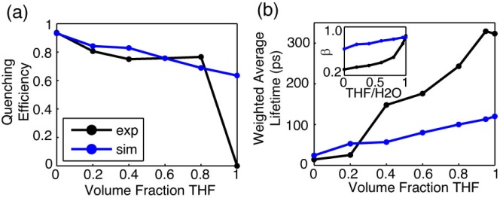

**Fig. 5.** Comparison of simulated (blue) and experimental (black) (a) quenching efficiency, (b) average lifetime, and (inset) KWW stretch parameter *ß* versus THF volume fraction for MEH-PPV.[similar critique as other figures with similar data]

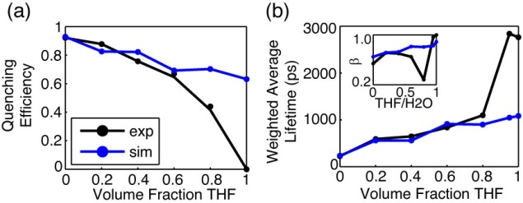

**Fig. 6.** Comparison of simulated (blue) and experimental (black) (a) quenching efficiency, (b) average lifetime, and (inset) KWW stretch parameter *ß* versus THF volume fraction for PFBT.[similar critique as other figures with similar data]

**Lattice ~~Gas~~ Swelling Model.** Monte Carlo simulations modeling the effect on exciton diffusion/energy transfer by swelling a cubic nanoparticle lattice with a constant number of quenchers[awk/unclear] were performed for each nanoparticle system.[awk/unclear] In order to approximate the number of quenchers, here defined as either redshifted or nonfluorescent chromophores, quenchers were added to an unswelled lattice of chromophores until the mean lifetime from 50 simulated nanoparticles (1000 excitons each) was reduced to the lifetime of the nanoparticles in water.[this needs to be unpacked a bit. It needs its own paragraph. See Xiaoli’s paper, or our previous paper. Also, some reference to your previous paper is needed.] In swelling the lattice, the nanoparticle size increased by a swelling factor initially derived from the ratio of swelled/unswelled nanoparticle volumes, given by, where *d* is the swelled lattice spacing, and *x* is the original nanoparticle lattice spacing, calculated to be 1.2 nm for PFBT, and 0.9 nm for MEH-PPV, respectively by taking the cube root of the volume of a single chromophore (taken to be two polymer repeat units).[you are leaving out details and trying to pack too much into a single sentence here. The physical picture needs to be explained: polymer taken to be a regular, cubic lattice of chromophores; energy transfer occurring between chromophores; ET rate set to reproduce exciton diffusion length observed; then give the rationale for the k-th power dependence on the swelling, etc.] The exciton hopping probability for a random walk is given by , where *t* is the time step, andD is the exciton diffusion constant given by , where is the lifetime of the polymer in good solvent. This hopping probability was reduced by a factor given by , using the assumption that the hopping probability as a function of lattice spacing is proportional to , where *k* is a constant, typically between 2-4 for excitonic systems, assumed to be 2 for these polymers.12 The time step size was adjusted so that the initial *phop* was ~0.01.[rework whole paragraph, and split it up, according to the above. Also, it is not a “lattice gas” model if all of the sites are occupied--in that case, it is just a “lattice model”.]



With the assumption that solvent swelling occurs in a similar fashion to other structurally similar polymers such as polystyrene (PS), the increases in the lattice spacing were calculated from data on dye-loaded PS beads swelled with THF.33 The number of quenchers for each polymer (assuming a quencher similar to perylene red with a quenching radius of 4 nm) was determined to be 9 for PFBT, and 10 for MEH-PPV. The greater number of quenchers per CPN than those previously reported for dye-doped PFBT CPNs can be ascribed to the use of a discrete lattice ~~gas~~ model with fixed hop distances as opposed to a continuum model with random hop distances.18[more detail is needed here. We also assume a cube in this case, whereas the other case was a sphere. Do we use the same diameter or the same volume? Might mention the number of quenchers used previously. Also, do the two models give substantially different values for beta? Are we including poisson distribution effects (or are they negligible)?] Generally, for both polymers, the single and bi-exponential fits to the simulated decays, as well as the quenching efficiency match the data very in the region of solvent quality where we assume that the polymer chains exist predominantly as a nanoparticle, and deviates substantially in the region of solvent ~~quality~~composition where we assume that nanoparticles and free polymer are coexisting in the solution (whether in a dynamic equilibrium or as two distinct phases).[I wouldn’t emphasize this region too much, or spend too much time on this “phase coexistence” or “dissociation” region, if we don’t have additional data (independent evidence of isolated molecules in solution) to back it up. Better to emphasize what does work, point out what doesn’t, and here just point to a later, separate paragraph, in which it is speculated that **perhaps** this might indicate some sort of equilibrium between particles and free polymer, and that further work needs to be done (i.e., Perahia’s neutron-scattering, or some light-scattering, or NMR, etc.] The stretched exponential parameters of the experimental PFBT data are reproduced in a similar fashion, matching well for the data at < 80% THF, and deviating at higher % THF. The simulated KWW time constants are somewhat higher for MEH-PPV, and *ß* is ~2x higher than the experimental MEH-PPV data. It is expected that the model data will diverge from the experimental data at higher THF volumes, given that the model does not simulate nanoparticle dissociation.[see above]

[you need to preface this with a bit about the defect model, and that we are trying to consider the effect of dimensionality on the system, as an alternative prespective, and in order to test our initial assumption that quenching by defects explains the discrepancy in lifetime and beta between free polymer and CPNs, which includes the assumption that defects don’t quench efficiently for the polymer free in solution, etc]The difference in quenching efficiency for a 3D PFBT particle (~92%) was compared to the quenching efficiency of a 1D chain of contour length where *Nchain* is the number of PFBT chains per 10 nm dia. particle, and *Lchain* is the approximate contour length of one chain of PFBT at the relevant molecular weight.[this probably needs to be fixed a bit, since while this was the initial physical picture I had in my head of unwinding a ball of yarn, the reviewer will want the chains to be present as isolated individual chains and not daisy-chained together. I think the quenching picture works out to be identical or at close enough, if the number of quenchers per chain is scaled properly and proper poisson stats are taken into account.] A number of Poisson distributed quenchers equal to the quantity obtained via simulation results were incorporated into the chain. The total quenched contour length results in ~9% quenching, which supports the notion that even with the same quantity of quenchers in the system, quenching is greatly suppressed as the nanoparticle dissociates [into free chains in solution?]. [this also supports one assumption of our quenching picture for CPNs: that quenching by defects is greatly reduced in isolated, extended chains.]



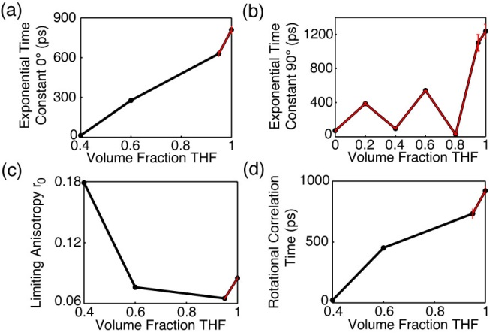

**Fig. 7.** (a,b) Single exponential time constants for parallel (0°) and perpendicular (90°) intensity decays of PFBT. (c,d) Limiting anisotropy and rotational correlation time of PFBT as a function of THF volume fraction.[these results look problematic. why is the time constant near zero for some values in (b)? Does it make sense to report a rotational correlation time (maybe a “phenomenological” one?)? Don’t you need to show some decays, and/or r(t) curves? I thought we only saw anisotropy for 95-100% THF, and even that was short-lived?]

**Picosecond Fluorescence Anisotropy Decay (FAD).** TCSPC was employed to measure polarized fluorescence intensity decays in order to calculate time-resolved anisotropy decay parameters.[awkward. also, font size trouble.] The process by which the anisotropy data is calculated from the fluorescence intensity decays at each polarizer orientation is given as follows. First, the total intensity decay law is determined from fitting the 55° data (the trial functions are single exponential for fluorescein in water and PFBT in THF, and KWW for the CPN samples). The parameters yielded from these fits (, or , *β*) are used as the first term of the trial decay for the 0° and 90° data. The second term in the trial decay function for the parallel or perpendicular data is given by a single exponential, so that the total trial decay function for a given sample is either a bi-exponential or a summed KWW and exponential decay



, (1)



where the superscript indicates the polarizer orientation. The fit results are then processed to determine the rotational correlation time , and the limiting anisotropy as follows. First, an amplitude correction factor, used to account for differences in SNR from run to run between the 55° data and the 0° (or 90°) data, is determined by, where the corrected amplitude (LHS) is calculated by multiplying the amplitude of the second exponential term in Equation 1 by the ratio of the 55° and the 0° (or 90°) KWW amplitudes. Thus, the corrected amplitude replaces the amplitude on the second term in Equation 1.Once the amplitudes are corrected, the rotational correlation time is calculated by a weighted average of the 0° and 90° lifetimes,



. (2)



In calculating r(t), the 55° terms drop out in the numerator due to the subtraction of I0(t) and I90(t), yielding

. (3)



Evaluating Equation 3 at t = 0 yields the limiting anisotropy ,



.  (4)



While complete anisotropy data was unable to be obtained for all except the highest % THF MEH-PPV samples (*r*0 = 0.07 r = 293 ps), owing to the fact that the majority of its anisotropy decays below the time resolution of our instrument,34 anisotropy data for PFBT is given in Fig. 7. The rotational correlation time [why is it so large--it should be much less than the excited state lifetime, if my recollection of the data is correct. Is there something odd about the numbers being put into the equation? Show me.] shows a general increasing trend, which reflects the parallel and perpendicular time constants from which r is calculated, indicating that the anisotropy decays more slowly as the volume fraction of THF increases. This is expected due to a reduction in exciton diffusion as the interchromophore distance increases due to swelling, and anisotropy loss is largely due to diffusive motion in good solvent. The low (~2x to ~50x lower than 0.4) limiting anisotropy values obtained for PFBT suggest that there is more anisotropy information at earlier times, below the time resolution of our instrument. Using the ratio of fluorescence lifetime to rotational correlation time, we can obtain an estimate of the number of exciton hops that occur within the mean exciton lifetime.30 For the case of PFBT CPNs in 40% THF (given that more anisotropy is observed for this sample, *r*0 = 0.18), the exciton lifetime is ~650 ps, and the rotational correlation time is ~20 ps. This corresponds to approximately 32 hops within the lifetime of each exciton. Compared to the free polymer in THF, with exp ~2800 ps and r ~900 ps, this corresponds to ~3 hops per lifetime, providing further evidence that exciton diffusion is favored in the aggregated state.[if this holds up, then perhaps you should consider how the number of hops affects the “linear-1D” case. Perhaps this means that 900 ps tells us the rate for hopping to a nearest-neighbor (two, actually, since each chromophore will have two neighbors). There are some assumptions in that picture (like, uncorrelated chromophore orientations), of course.]

**CONCLUSION**

The solvent quality dependence of photophysical parameters of PFBT and MEH-PPV CPNs was assessed. The quantum yield of both systems increases with increasing THF concentration, eventually reproducing the quantum yield for free polymer at 95% THF. Spectral data of MEH-PPV exhibits significant blue shifting as solvent quality is improved, with an approximate isosbestic point between the nanoparticle and free polymer spectra of 80% THF. Bi-exponential lifetime data suggests an isosbestic point of 80% for PFBT, and 40% for MEH-PPV. A lattice gas exciton diffusion, energy transfer model yielded 9 and 10 quenchers/particle for PFBT and MEH-PPV respectively, with good agreement to experimental data at THF concentrations where nanoparticle dissociation is not prominent. Time-resolved fluorescence anisotropy decay analysis allowed for the determination of the number of exciton hops per lifetime of ~32 for swelled PFBT CPNs and ~3 hops for PFBT in THF, supporting the notion that exciton diffusion is effectively shut down in good solvent.[much of this will likely change, but I’ll wait until next draft.]

**ACKNOWLEDGMENTS**

We acknowledge financial support from the NSF under Grant No. CHE-1058885.

**REFERENCES**

(1) Dennler, G., and Sariciftci, N. S. Flexible Conjugated Polymer-Based Plastic Solar Cells: From Basics to Applications. *Proc. IEEE* **2005**, *93*, 1429-1439.

(2) Yim, K. H., Zheng, Z., Liang, Z., Friend, R. H., Huck, W. T. S., and Kim, J. S. Efficient Conjugated-Polymer Optoelectronic Devices Fabricated by Thin-Film Transfer-Printing Technique. *Adv Funct Mater* **2008**, *18*, 1012-1019.

(3) Wu, C. F.; Szymanski, C.; Cain, Z.; McNeill, J. Conjugated Polymer Dots for Multiphoton Fluorescence Imaging. *J. Am. Chem. Soc.* **2007**, *129*, 12904-12905.

(4) Yu, J., Wu, C. F., Sahu, S. P., Fernando, L. P., Szymanski, C., and McNeill, J. Nanoscale 3D Tracking with Conjugated Polymer Nanoparticles. *J. Am. Chem. Soc.* **2009**, *131*, 18410-18414.

(5) Wu, C. F., Bull, B. Christensen, K. and McNeill, J. Ratiometric Single-Nanoparticle Oxygen Sensors for Biological Imaging. *Angew. Chem., Int. Ed.* **2009**, *48*, 2741-2745.

(6) Wu, C. F.; Bull, B.; Szymanski, C.; Christensen, K.; McNeill, J. Multicolor Conjugated Polymer Dots for Biological Fluorescence Imaging. *ACS Nano* **2008**, *2*, 2415-2423.

(7) Wu, C. F.; Schneider, T.; Zeigler, M.; Yu, J. B.; Schiro, P. G.; Burnham, D. R.; McNeill, J. D.; Chiu, D. T. Bioconjugation of Ultrabright Semiconducting Polymer Dots for Specific Cellular Targeting. *J. Am. Chem. Soc.* **2010**, *132*, 15410-15417.

(8) Wu, C. F.; Chiu, D. T. Highly Fluorescent Semiconducting Polymer Dots for Biology and Medicine. *Angew. Chem., Int. Ed.* **2013**, *52*, 3086-3109.

(9) Koner, A. L.; Krndija, D.; Hou, Q.; Sherratt, D. J.; Howarth, M. Hydroxy-Terminated Conjugated Polymer Nanoparticles Have Near-Unity Bright Fraction and Reveal Cholesterol-Dependence of IGF1R Nanodomains. *ACS Nano* **2013**, *7*, 1137-1144.

(10) Read, N.; Sachdev, S.; Ye, J. Landau Theory of Quantum Spin-Glasses of Rotors and Ising Spins. *Phys. Rev. B* **1995**, *52*, 384-410.

(11) Kasha, M.; Rawls, H. R.; Ashraf El-Bayoumi, M. The Exciton Model in Molecular Spectroscopy. *Pure and Applied Chemistry* **1965**, *11*, 371-392.

(12) Emelianova, E. V., Athanasopoulos, S., Silbey, R. J., and Beljonne, D. 2D Excitons as Primary Energy Carriers in Organic Crystals: The Case of Oligoacenes. *Phys. Rev. Lett.* **2010**, *104*, 206405-206408.

(13) Lunt, R. R., Giebink, N. C., Belak, A. A., Benzinger, J. B., and Forrest, S. R. Exciton Diffusion Lengths of Organic Semiconductor Thin Films Measured by Spectrally Resolved Photoluminescence Quenching. *J. Appl. Phys.* **2009**, *105*, 053711-053717.

(14) Gammill, L. S.; Powell, R. C. Energy-Transfer in Perylene Doped Anthracene-Crystals. *Mol. Cryst. Liq. Cryst.* **1974**, *25*, 123-130.

(15) Powell, R. C.; Kepler, R. G. Evidence for Long-Range Exciton-Impurity Interaction in Tetracene-Doped Anthracene Crystals. *Phys. Rev. Lett.* **1969**, *22*, 636-639.

(16) Athanasopoulos, S.; Hoffman, S. T.; Bassler, H.; Kohler, A.; Beljonne, D. To Hop or Not to Hop? Understanding the Temperature Dependence of Spectral Diffusion in Organic Semiconductors. *J. Phys. Chem. Lett.* **2013**, *4*, 1694-1700.

(17) Scholes, G. D., and Rumbles, G. Excitons in Nanoscale Systems. *Nature Materials* **2006**, *5*, 683-696.

(18) Groff, L. C.; Wang, X. L.; McNeill, J. D. Measurement of Exciton Transport in Conjugated Polymer Nanoparticles. *J. PHys. Chem. C* **2013**, *117*, 25748-25755.

(19) Wang, X. L.; Groff, L. C.; McNeill, J. D. Photoactivation and Saturated Emission in Blended Conjugated Polymer Nanoparticles. *Langmuir* **2013**, *29*, 13925-13931.

(20) Sun, K.; Chen, H.; Wang, L.; Yin, S.; Wang, H.; Xu, G.; Chen, D.; Zhang, X. J.; Wu, C. F.; Qin, W. P. Size Dependent Property and Cell Labeling of Semiconducting Polymer Dots. *ACS Appl. Mater. Interf.* **2014**, *In Press*.

(21) Burkalov, V. M., Kawata, K., Assender, H. E., Briggs, G. A. D., Ruseckas, A., and Samuel, I. D. W. Discrete Hopping Model of Exciton Transport in Disordered Media. *Phys. Rev. B* **2005**, *72*, 075206-075210.

(22) Jelly, E. E. Molecular, Nematic and Crystal States of I: I-Diethyl--Cyanine Chloride. *Nature (London)* **1936**, *139*, 631-632.

(23) Hayer, A., Van Regemorter, T., Höfer, B., Mak, C. S. K., Beljonne, D., and Köhler, A. On the Formation Mechanism for Electrically Generated Exciplexes in a Carbazole-Pyridine Copolymer. *J. Polym. Sci. Part B: Polym. Phys.* **2012**, *50*, 361-369.

(24) McNeill, J. D.; Barbara, P. F. NSOM Investigation of Carrier Generation, Recombination, and Drift in a Conjugated Polymer. *J. PHys. Chem. B* **2002**, *106*, 4632-4639.

(25) Hintschich, S. I.; Rothe, C.; Sinha, S.; Monkman, A. P.; de Freitas, P. S.; Scherf, U. Population and Decay of Keto States in Conjugated Polymers. *J. Chem. Phys.* **2003**, *119*, 12017-12022.

(26) Wu, C. F., Peng, H., Jiang, Y. and McNeill, J. Energy Transfer Mediated Fluorescence from Blended Conjugated Polymer Nanoparticles. *J. PHys. Chem. B* **2006**, *110*, 14148-14154.

(27) Wu, C. F., Zheng, Y. L., Szymanski, C., and McNeill, J. Energy Transfer in a Nanoscale Multichromophoric System: Fluorescent Dye-Doped Conjugated Polymer Nanoparticles. *J. PHys. Chem. C* **2008**, *112*, 1772-1781.

(28) Yang, Z.; Huck, W. T. S.; Clarke, S. M.; Tajbakhsh, A. R.; Terentjev, E. M. Shape-Memory Nanoparticles from Inherently Non-Spherical Polymer Colloids. *Nature Materials* **2005**, *4*, 486-490.

(29) Dias, F. B.; Macanita, A. L.; de Melo, J. S.; Burrows, H. D.; Guntner, R.; Scherf, U.; Monkman, A. P. Picosecond conformational relaxation of singlet excited polyfluorene in solution. *J. Chem. Phys.* **2003**, *118*, 7119-7126.

(30) Martini, M.; Roux, S.; Montagna, M.; Pansu, R.; Julien, C.; Tillement, O.; Perriat, P. How gold inclusions increase the rate of fluorescein energy homotransfer in silica beads. *Chem Phys Lett* **2010**, *490*, 72-75.

(31) Szymanski, C., Wu, C. F., Hooper, J., Salazar, M. A., Perdomo, A., Dukes, A., and McNeill, J. Single Molecule Nanoparticles of the Conjugated Polymer MEH-PPV, Preparation and Characterization by Near-Field Scanning Optical Microscopy. *J. PHys. Chem. B* **2005**, *109*, 8543-8546.

(32) Chen, R. Apparent Stretched-Exponential Luminescence Decay in Crystalline Solids. *J. Lumin.* **2003**, *102*, 510-518.

(33) Lee, J. H.; Gomez, I. J.; Sitterle, V. B.; Meredith, J. C. Dye-labeled polystyrene latex microspheres prepared via a combined swelling-diffusion technique. *J Colloid Interf Sci* **2011**, *363*, 137-144.

(34) Collini, E.; Scholes, G. D. Coherent Intrachain Energy Migration in a Conjugated Polymer at Room Temperature. *Science* **2009**, *323*, 369-373.